CoCIS Smart Control and Monitoring System Report
Course: BSE III, Embedded Systems
Repository:https://github.com/MukyalaDorcusNandy/cocis-smart-system
Firmware: ESP-IDF v6.0.1 on one ESP32 DevKit C v4, simulated in Wokwi
Wokwi link: https://wokwi.com/projects/479973565868386305
Name | Registration no. | Component owned
Mukyala Dorcus Nandy | 23/U/11911/EVE | Entrance: access control, doors (access_control); MFRC522 readers and driver (rfid); card roles, colours, buzzer pattern
Mariam Wambui | 23/U/18494/PS | Lecture rooms: PIR occupancy and lighting (room_control); rooms on the web dashboard
Kisomose Arnold Patrick | 23/U/10079/EVE | Lecture rooms (room_control), project structure and circuit (diagram.json layout, pin plan, wokwi.toml, sdkconfig.defaults); entrance LCD (lcd_display)
Katumba Joshua Mugwanya | 23/U/09330/PS | Storage and SD log, schedule and clock, authentication, management commands; web sign-in security
Nannyombi Shakiran | 23/U/11963/EVE | System integration: main.c and the hub task; Wi-Fi and web Security Dashboard (web_dashboard)

Table of Contents

1. Introduction 1
1.1 Aim and objectives 1
1.2 Scope 1
1.3 Organisation of the report 2
2. System operation 2
2.1 Architecture 2
2.2 Communication between the three terminals 4
2.3 Hardware components and pin plan 5
2.4 Software design 8
2.5 Synchronisation 10
2.6 Implemented features and serial menu 12
2.7 Requirements coverage 13
2.8 Innovation and additional features 14
2.9 The system running (screenshots) 16
3. Wokwi simulation link 20
4. Individual video demonstrations 21
5. Individual contributions 22
5.1 Mukyala Dorcus Nandy: entrance and access control 22
5.2 Mariam Wambui: lecture-room occupancy and lighting 23
5.3 Kisomose Arnold Patrick: room component, project structure, circuit and entrance LCD 23
5.4 Katumba Joshua Mugwanya: storage, schedule, authentication and management 24
5.5 Nannyombi Shakiran: system integration and hub 24
6. Testing and limitations 25
6.1 Integration tests 25
6.2 Limitations 26

List of Figures
Figure 1 : FreeRTOS task dataflow and access-control pipeline 4
Figure 2 : Wokwi circuit of the CoCIS Smart Control and Monitoring System 6
Figure 3 : Serial console output at start-up 16
Figure 4 : Access granted at the ENTRY reader 17
Figure 5 : Access denied for an unregistered NFC tag 18
Figure 6 : Security Dashboard sign-in page 19
Figure 7 : Security Dashboard showing occupants, live alerts and the admin panel 20

List of Tables
Table 1 : Firmware components, their roles and the FreeRTOS tasks they run 2
Table 2 : Hardware components and ESP32 pin assignments 6
Table 3 : Shared data and the synchronisation used to protect it 10
Table 4 : Serial console commands and the login they require 12
Table 5 : Mapping of the coursework requirements to the implemented system 13
Table 6 : Innovations and additional features 14
Table 7 : Individual video demonstrations 21
Table 8 : Integration tests and what each one shows 25

List of Abbreviations
API Application Programming Interface
ATQA Answer To Request, Type A
BCC Block Check Character
CoCIS College of Computing and Information Sciences
CS Chip Select
ESP-IDF Espressif IoT Development Framework
FIFO First In, First Out
GPIO General-Purpose Input/Output
HTTP Hypertext Transfer Protocol
HTTPS Hypertext Transfer Protocol Secure
I2C Inter-Integrated Circuit
ID Identifier
IoT Internet of Things
IP Internet Protocol
JSON JavaScript Object Notation
LCD Liquid Crystal Display
LED Light-Emitting Diode
LEDC LED Control (ESP32 PWM peripheral)
MB Megabyte
MISO Master In, Slave Out
MOSI Master Out, Slave In
NFC Near-Field Communication
NVS Non-Volatile Storage
PIN Personal Identification Number
PIR Passive Infrared
PWM Pulse-Width Modulation
RAM Random-Access Memory
REQA Request Command, Type A
RFID Radio-Frequency Identification
RGB Red, Green, Blue
RST Reset
RTOS Real-Time Operating System
RX Receive
SCK Serial Clock
SCL Serial Clock Line
SD Secure Digital
SDA Serial Data Line
SHA-256 Secure Hash Algorithm, 256-bit
SPI Serial Peripheral Interface
TX Transmit
UART Universal Asynchronous Receiver-Transmitter
UID Unique Identifier
VS Code Visual Studio Code
WUPA Wake-Up Command, Type A

1. Introduction
This report presents the Smart Control and Monitoring System that our group designed and implemented for the CoCIS pilot, which covers the main building entrance and two lecture rooms. The system controls and records access to the building with RFID, switches lecture-room lights automatically according to occupancy, and gives management a secure way to monitor the building through a serial menu and a Wi-Fi Security Dashboard. It is written in C with ESP-IDF and FreeRTOS for the ESP32 microcontroller and is demonstrated on the Wokwi simulator.

1.1 Aim and objectives
The aim of the project is to design, implement and demonstrate in simulation an embedded system that controls access to the CoCIS building, automates lighting in the lecture rooms, and gives management a secure way to monitor the building. The specific objectives are to:
- identify every person at the entry and exit points using two MFRC522 RFID readers, and open the matching door only for valid, unblocked cards within the opening hours;
- keep an accurate record of who is inside the building and prevent the same card from being used to enter twice (anti-passback);
- detect occupancy in each lecture room with a PIR motion sensor and switch the lights on and off automatically;
- record every access decision and system event, with a timestamp, on an SD card;
- allow only an authenticated administrator to change the opening hours and other settings;
- give management a serial console and a Wi-Fi Security Dashboard for viewing access records, occupancy, room and lighting status, and live alerts; and
- protect shared data with mutexes and queues so that the entrance and both lecture rooms work reliably as one system.

1.2 Scope
The whole system runs on a single ESP32 DevKit C v4. Because the free Wokwi setup supports only one microcontroller, the three terminals described in the brief (the building entrance, lecture room 1 and lecture room 2) are implemented as separate groups of FreeRTOS tasks on the same chip instead of separate boards. Wi-Fi is used only for the Security Dashboard. The system has been tested in simulation only; its limitations are discussed in Section 6.2.

1.3 Organisation of the report
The rest of the report is organised as follows. Section 2 explains how the system operates: its architecture, the communication between the terminals, the hardware, the software design, synchronisation, the implemented features, how the coursework requirements are met, the innovations added beyond the brief, and screenshots of the running system. Section 3 gives the Wokwi simulation link and the steps to run it. Section 4 links each member’s video demonstration, Section 5 describes the individual contributions, and Section 6 covers testing and limitations.

2. System operation
This section explains how the system works: its architecture, the communication between the entrance and the two lecture rooms, the hardware, the software design, synchronisation and the implemented features.

2.1 Architecture
The firmware is split into ten ESP-IDF components, each owned by one or two members. main.c starts them in a fixed order: storage, schedule, auth, hub, management commands, web dashboard commands, entrance LCD, room 1, room 2, entrance, RFID readers, Wi-Fi + web server.
Table 1: Firmware components, their roles and the FreeRTOS tasks they run
Component | Role | Tasks it runs
access_control | Entrance: card decisions, roles and colours, doors, LEDs, buzzer, serial console | access (priority 5), actuator (4), console (3)
rfid | Two MFRC522 readers (software SPI, own CS and MISO each); sends each new card to the entrance | rfid (4)
lcd_display | 16x2 I2C LCD at the entrance: welcome / denied message, idle clock | lcd (3)
web_dashboard | Wi-Fi, HTTP server, PIN sign-in, live alerts, admin actions | ESP-IDF httpd (5) and Wi-Fi tasks
room_control | One instance per room: PIR occupancy and light control | room1, room2 (5)
hub (in cocis_system/main) | Collects room reports and entrance events, detects offline rooms | hub (6)
storage | Settings in NVS flash; event log on the SD card plus a RAM copy | none
schedule | The single clock and the opening hours | none
auth | Admin PIN, login sessions, lockout | none
management | Admin commands added to the entrance console | none
Figure 1 shows how these tasks exchange data through FreeRTOS queues.
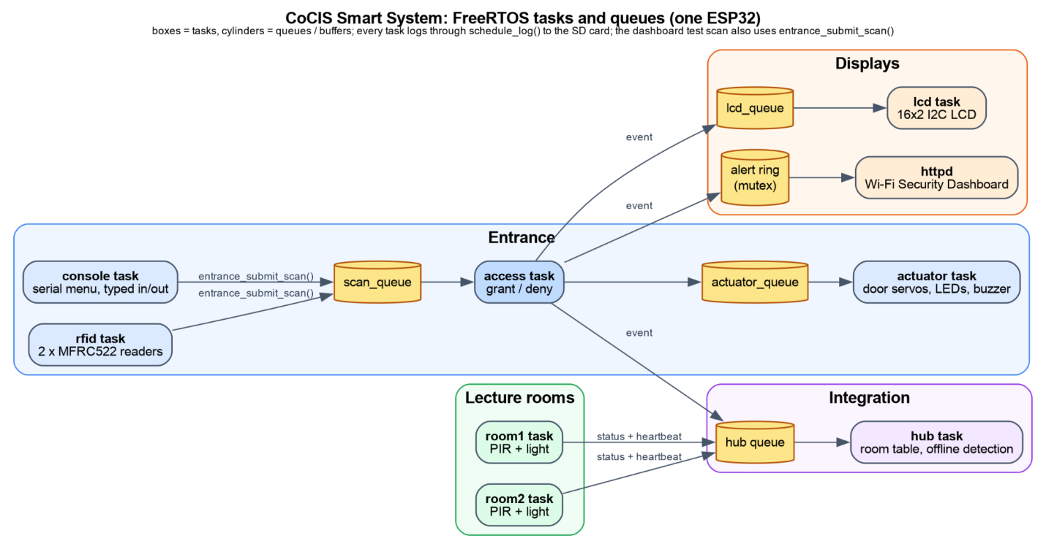
Figure 1: FreeRTOS task dataflow and access-control pipeline

2.2 Communication between the three terminals
How these three terminals communicate inside the one chip:
- Entrance. The rfid task reads the two readers. Each new card goes through entrance_submit_scan() as a message on scan_queue. A typed in/out and the web test scan use the same function. The access task decides and sends a door command on actuator_queue. The actuator task moves the servo and drives the LEDs and buzzer, so a 3-second door opening never blocks the next decision.
- Rooms to hub. Each room task sends its status (occupied, light on, light-on time, sequence number) on the hub queue whenever it changes, and as a heartbeat every 5 s.
- Entrance to hub, web and LCD. Every entry or exit decision, granted or denied, is sent to every listener (up to 4): the hub, the web dashboard's alert ring and the LCD queue.
- Offline detection. If a room sends nothing for 15 s (three missed heartbeats), the hub marks it OFFLINE and logs it. It returns to ONLINE on the next report.
- Lost messages. Callbacks never wait on the hub queue. If the queue is full, the drop is printed. A room retries on the next heartbeat.
- Duplicates. Each room report carries a sequence number. The hub ignores a report whose sequence matches the last one it stored.

2.3 Hardware components and pin plan
All parts are wired to the one ESP32 DevKit C v4, as shown in Figure 2. Table 2 gives the full pin plan, which has no clashes.
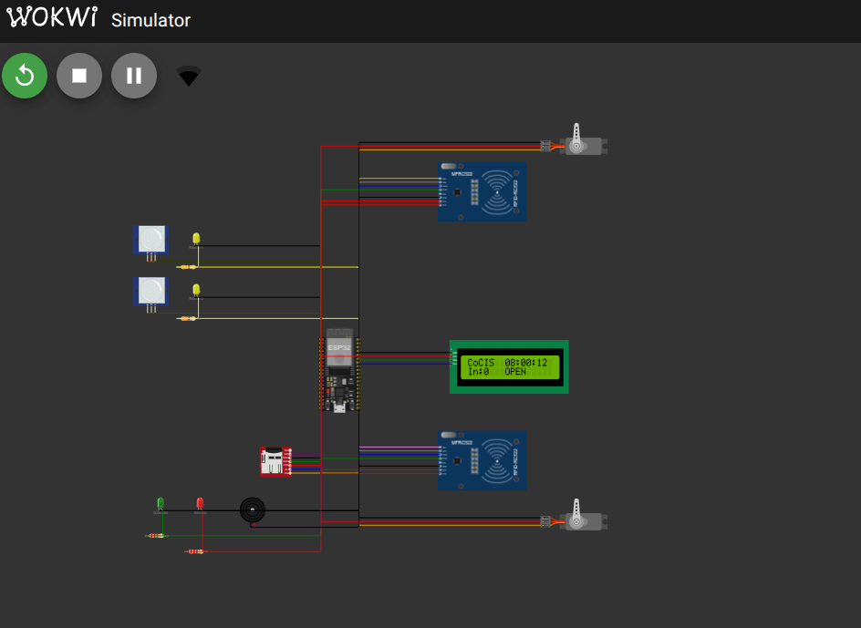
Figure 2: Wokwi circuit of the CoCIS Smart Control and Monitoring System
In Figure 2, the two lecture rooms (PIR sensor and light) are at the top left. The ENTRY reader and door are at the top right, followed by the LCD, with the EXIT reader and door at the bottom right. The SD card, the green and red LEDs and the buzzer are at the bottom left.
Table 2: Hardware components and ESP32 pin assignments
Part | Purpose | ESP32 pins
PIR motion sensor (room 1) | Detects motion in room 1 | GPIO 32
Yellow LED + 330 Ω (room 1) | Room 1 lights | GPIO 21
PIR motion sensor (room 2) | Detects motion in room 2 | GPIO 33
Yellow LED + 330 Ω (room 2) | Room 2 lights | GPIO 22
Servo (entry door) | Opens the entry door for 3 s | GPIO 18 (PWM, 50 Hz)
Servo (exit door) | Opens the exit door for 3 s | GPIO 19 (PWM, 50 Hz)
Green LED + 220 Ω | Access granted | GPIO 25
Red LED + 220 Ω | Access denied | GPIO 26
Buzzer (volume 1) | One short beep when granted, two long beeps when denied (2 kHz) | GPIO 27
16x2 LCD (wokwi-lcd1602, I2C, address 0x27) | Welcome / denied message and the idle clock at the entrance | SDA 15, SCL 2
MFRC522 reader, ENTRY (board-mfrc522) | Reads cards at the entry door | Software SPI: SCK 16, MOSI 17, MISO 35, SDA (CS) 5; RST to 3.3 V
MFRC522 reader, EXIT (board-mfrc522) | Reads cards at the exit door | same SCK 16 / MOSI 17, own MISO 36 (VP), SDA (CS) 23; RST to 3.3 V
microSD card (SPI2) | Log file ACCESS.LOG | SCK 14, MOSI 13, MISO 34, CS 4
Serial monitor (UART0, 115200 baud) | Admin menu, backup typed scans | TX / RX
Wi-Fi (built in) | Joins Wokwi-GUEST; web dashboard on port 80 → http://localhost:8180 | —
The RFID readers. The two readers are Wokwi's official board-mfrc522 part. They share one SPI bus (SCK and MOSI), but each has its own chip-select (SDA) and MISO line, and RST is tied to 3.3 V so the readers always run.
The entrance LCD. When idle, the LCD shows CoCIS HH:MM:SS and In:N OPEN (or CLOSED). After every scan it shows the result for 3 s: WELCOME Brian / Student BLUE card, BYE ... on exit, or DENIED ... with a short reason (Building closed, Already inside, Unknown card, Card blocked, Not inside).

2.4 Software design
RFID driver (rfid.c). It is a hand-written, register-level driver (no library). SPI is done in software (bit-banged), so each reader can have its own MISO line. At start-up the driver resets each reader, sets a timeout of about 25 ms, turns the antenna on and reads the version register to confirm that the reader is present; a missing reader is reported at boot, and typed scans still work. About every 50 ms the rfid task asks each reader:
- WUPA (wake up, 7 bits): a card answers with 2 bytes (ATQA). If not, there is no card (tried twice).
- Anticollision (0x93 0x20): the card sends 4 UID bytes + BCC. The driver checks BCC = UID0 ^ UID1 ^ UID2 ^ UID3, so a corrupted read is ignored. The grey NFC Tag has a 7-byte UID (04:11:22:33:44:55:66); in Wokwi it answers with its first 4 bytes, so it reads as 04112233. That ID is not registered, so it is denied as an unknown tag.
- Debounce: a card is reported once ([RFID ENTRY] card 01020304). The same card is reported again only after 2 empty polls (card removed).
Card roles and colours. Every card has a role: Student (blue), Staff (green), Guest (yellow), Admin (red). The test cards match the Wokwi card presets, so the colour of the card you tap is the role colour. The LCD shows it (Student BLUE card), inside and users print the role and colour, inside also shows the time the person came in, and the dashboard shows a colour chip.
Entrance decision. For each scan the access task checks, in this order:
- Is the card registered? If not: unknown tag.
- Is it blocked (lost or stolen)? If so: tag blocked.
- Entry only: is the person already inside? If so: already inside (anti-passback).
- Exit only: is the person inside? If not: not inside.
- Is the building open now? If not, entry is denied, and exit is denied unless emergency mode is on (outside access hours or emergency exit).
A granted decision updates the “who is inside” record, opens the matching door for 3 s, lights the green LED and gives one short beep. A denied one lights the red LED and gives two long beeps. Every decision is printed, shown on the LCD and written to the system log.
Safety note. The assignment restricts both entry and exit outside configured hours. A real building must always preserve emergency egress. In this simulation, exit is denied outside hours unless an authenticated administrator turns on emergency mode. That models the coursework rule and still provides a safe override.
Room control. Each room task polls its PIR every 100 ms. Motion switches the light on at once. The light goes off 10 s after the last motion (a demo value; about 5 minutes in real use), because a PIR sees movement, not presence. Each room also adds up how long its light has been on.
Schedule and clock. One simulated clock starts at 08:00 at boot. The default opening hours are 08:00–18:00. Opening time must be before closing time. The hours are saved in NVS, so they survive a reset.
Storage and logging. At boot the SD card is mounted over SPI and every event is appended to /sdcard/ACCESS.LOG as seq,HH:MM:SS,EVENT,details. The last 20 lines are also kept in RAM. If the card cannot be mounted, or a write fails, the system keeps running in RAM-only mode and says so at boot. Logged events include card decisions, room changes, rooms going offline, logins, schedule and clock changes, emergency mode and card blocking.
Web Security Dashboard (web_dashboard). wifi.c joins the open Wokwi network Wokwi-GUEST and keeps retrying in the background, so the rest of the system never waits for Wi-Fi. web_dashboard.c runs an HTTP server on port 80, which Wokwi forwards to http://localhost:8180. The page is built into the firmware and refreshes every 1.5 s. It shows the number of people inside per role, who is inside (colour chips and entry time), who is out, the state of each room and a live alert feed. Every new alert pops up with a beep, and a denied, unknown or blocked card raises a red SECURITY ALERT with an alarm tone. From the page an admin can set the opening hours, turn emergency mode on or off, block or unblock a card and make a test scan.
Web sign-in. The dashboard uses the same admin PIN and the same lockout counter as the console (three tries, then 30 s), so switching between console and web gives no extra guesses. A correct PIN returns a random session token that every request must carry; without it, or after 10 minutes idle, the page returns to sign-in. Web sign-ins and admin actions are written to the system log.
Authentication. Changing any setting needs an admin login. The PIN is never stored in plain text: NVS holds a random 16-byte salt and the SHA-256 hash of salt + PIN, compared in constant time. Three wrong PINs lock login for 30 s. A session ends after 120 s without a protected command. The default PIN 1234 is created on first boot and the system warns until it is changed. The PIN is never printed or logged, and the console shows **** while it is typed.

2.5 Synchronisation
Every shared record has one owner and one lock, so two tasks never update it at the same time.
Table 3: Shared data and the synchronisation used to protect it
Shared data | Protected by | Used by
Card table, inside flags, inside count, entrance log | state_mutex | access task, console commands
Each room’s status | the room’s own mutex | room task, hub
Room table in the hub (online / last report) | hub mutex | hub task, rooms command
Clock and opening hours | schedule mutex | entrance, management commands
Log ring and SD file | storage mutex | every component that logs
Login session and lockout (one counter for console and web) | auth mutex | management commands, web sign-in
The two readers (shared SCK/MOSI) | Only the rfid task talks to them, one at a time; own CS and own MISO line per reader; reader status guarded by state_lock | rfid task, rfid command
LCD screen | only the lcd task writes it; decisions reach it through lcd_queue | lcd task
Web alert ring (30 alerts) and session token | s_lock mutex in web_dashboard | access task (writes alerts), HTTP task (reads)
Tasks pass work through queues instead of calling each other: scan_queue (fed by the rfid task, the console and the web through entrance_submit_scan()) and actuator_queue at the entrance, the hub queue for room and entrance events, and lcd_queue for the LCD. The callbacks that feed the hub only enqueue a message with no wait, so a slow hub can never stall a room or the entrance.
Building occupancy has one owner: access_control. The hub does not keep a second copy. The rooms command asks the entrance (entrance_inside_count()) and the web page asks for a copy of the card table (entrance_get_users()), so a dropped message cannot make occupancy inconsistent.

2.6 Implemented features and serial menu
All commands are typed in the Wokwi serial monitor. Viewing needs no login; changing a setting does. Command names follow the coursework suggestions (HELP, STATUS, WHO_INSIDE, ROOMS, LOGS, SET_SCHEDULE) with shorter words that fit a serial console.
Table 4: Serial console commands and the login they require
Command | What it does | Login
in <UID> / out <UID> | Backup: typed card scan at the entry or exit reader | no
inside | Who is inside and how many, with role, colour and since-time | no
log | Recent entrance decisions | no
status | Clock, hours, open or closed, emergency mode, people inside | no
rooms | Each room: online or offline, occupied or empty, light on or off, light-on time; building occupancy | no
users | Registered cards: role, colour, inside/outside, blocked | no
wifi | Wi-Fi status, IP and dashboard address | no
hours / clock | Show opening hours / show the clock | no
login <pin> / logout | Start or end an admin session | no
setpin <new> | Change the admin PIN (4–8 digits) | yes
hours HH:MM HH:MM | Set opening hours | yes
clock HH:MM | Set the simulated clock | yes
syslog [n] | Last n system log lines from RAM and the SD card | yes
emergency on|off | Allow exit outside opening hours | yes
block <UID> / unblock <UID> | Block or unblock a lost or stolen card (saved in NVS) | yes
roomfail <n> on|off | Test aid: make a room stop reporting, to show offline detection | yes
help | List all commands | no
Registered cards are fixed in the firmware and match the Wokwi card presets: Alice (Staff) Green Card 11223344, Brian (Student) Blue Card 01020304, Grace (Guest) Yellow Card 55667788, Dan (Admin) Red Card AABBCCDD, and the lost card, the orange Key Fob C0FFEE99, which starts blocked. Carol (Student, blue) C3D4E5F6 has no Wokwi card and is used with typed scans.
The web dashboard gives the same information in a browser, plus live alerts (Section 2.4).

2.7 Requirements coverage
Table 5: Mapping of the coursework requirements to the implemented system
Brief | How the system meets it
RFID access | Two MFRC522 readers (Wokwi board-mfrc522, own register-level driver); registered vs unknown vs blocked cards; grant/deny drives doors, LEDs, buzzer and the LCD
Entry and exit tracking | Two scan points, anti-passback, “who is inside” record and count (inside)
Two smart rooms | PIR per room; light on with motion, off 10 s after the last motion
Single ESP32 | One DevKit in diagram.json; entrance and both rooms share this controller
Data storage | Access decisions, occupancy changes and system activity appended to ACCESS.LOG (NVS for settings; RAM fallback if SD fails)
Serial management interface | help, status, inside, rooms, log, syslog, wifi, plus protected setting commands. Extra interface: the web Security Dashboard
Configurable schedule | Default 08:00–18:00; only a logged-in admin (console or web) can change hours or the clock; entrance enforces the hours
Authentication | Salted SHA-256 PIN, lockout, idle timeout; schedule and other privileged commands require login
Synchronisation | One mutex per shared record, one owner for occupancy, queues between tasks, one task owning both readers (Section 2.5)

2.8 Innovation and additional features
These features go beyond the basic requirements:
Table 6: Innovations and additional features
Feature | Why it helps
Two MFRC522 readers with a hand-written register-level driver (no library) | The driver does the SPI itself (bit-banged), REQA/WUPA, anticollision and the BCC check, reads the FIFO in one burst, and gives each reader its own chip select and MISO line. The rfid command shows each reader's status. The same code would work with a real reader.
Entrance LCD | A 16x2 I2C LCD greets the person by name with role and card colour, gives a short reason when denied, and shows the clock, people inside and OPEN/CLOSED when idle.
Colour-coded roles | Student blue, Staff green, Guest yellow, Admin red, matching the Wokwi card colours. A guard sees at a glance who came in; the colour is also on the LCD, the console and the dashboard.
Wi-Fi Security Dashboard with live alerts | Security staff watch who is inside, who is out and the rooms from a browser. Denied, unknown and blocked cards pop up as red alerts with an alarm tone.
Shared lockout across console and web | One failure counter for both, so an attacker cannot get extra PIN guesses by switching interface.
Offline detection | A room that stops reporting for 15 s is shown OFFLINE and logged.
Emergency mode | An admin can allow exit outside opening hours (safe egress), and it is logged.
Salted PIN hash | The PIN is stored as salt + SHA-256 hash, compared in constant time, never printed or logged.
SD logging with RAM fallback | Every event goes to ACCESS.LOG; if the card fails, the system keeps a RAM log and says so.

2.9 The system running (screenshots)
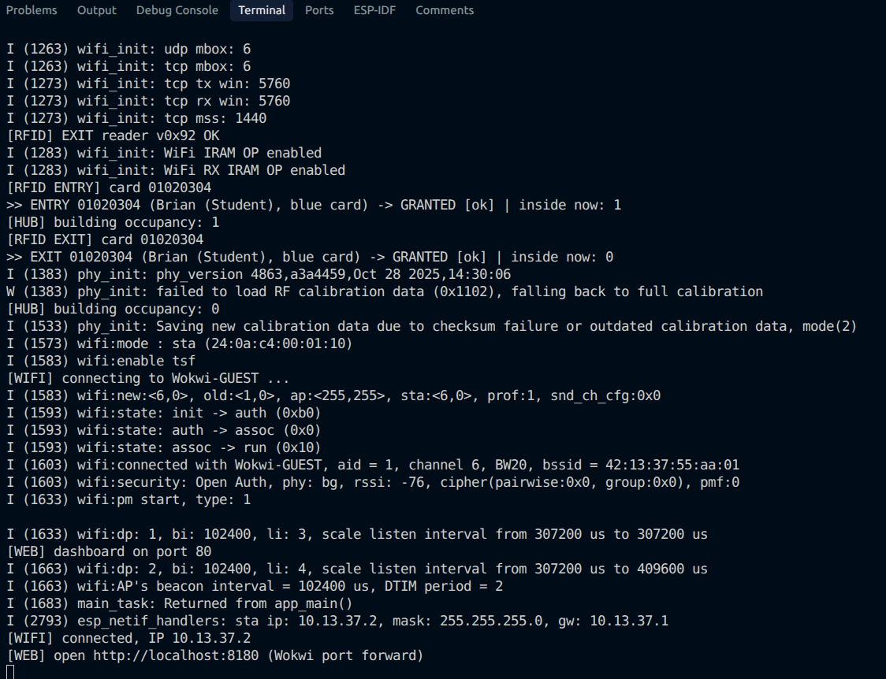
Figure 3: Serial console output at start-up
Figure 3 shows the serial output at start-up. Both MFRC522 readers answer (v0x92 OK), the Blue Card is read at ENTRY and then at EXIT, the hub updates the building occupancy, and the ESP32 joins Wi-Fi and starts the dashboard ([WEB] dashboard on port 80).
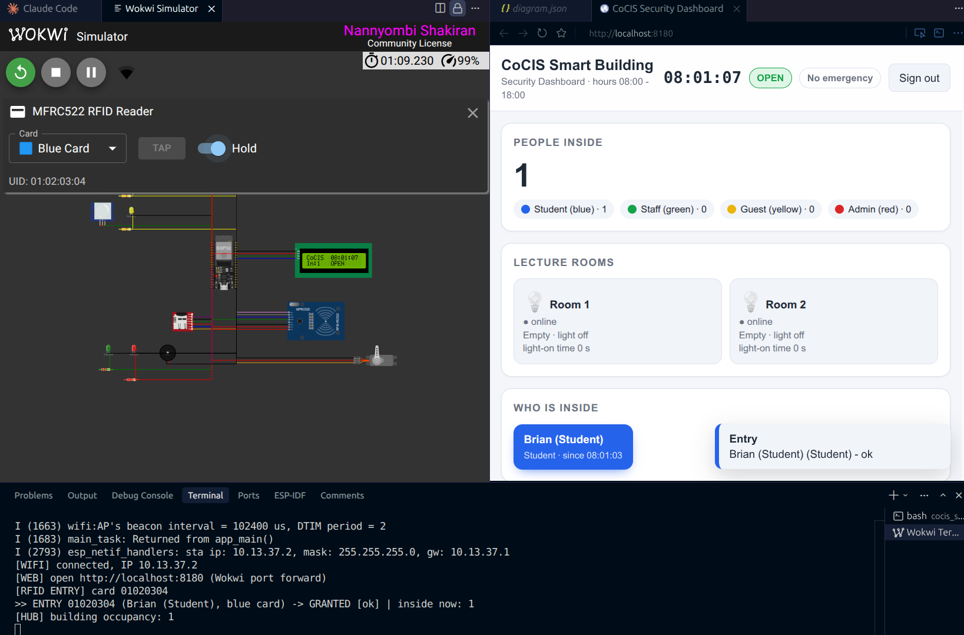
Figure 4: Access granted at the ENTRY reader
In Figure 4, the Blue Card is held on the ENTRY reader (UID 01:02:03:04). The console prints [RFID ENTRY] card 01020304 and GRANTED, the LCD shows the person inside (In:1), and the dashboard shows Brian as a blue Student chip with the time of entry.
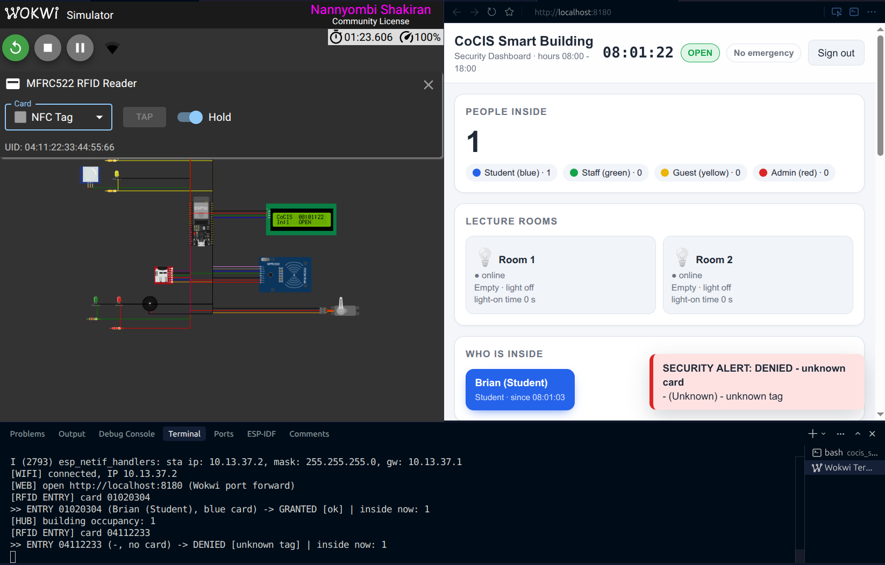
Figure 5: Access denied for an unregistered NFC tag
Figure 5 shows a denied scan. The NFC Tag is not registered, so the console prints DENIED [unknown tag] and the dashboard pops up a red SECURITY ALERT: DENIED - unknown card, with an alarm tone.
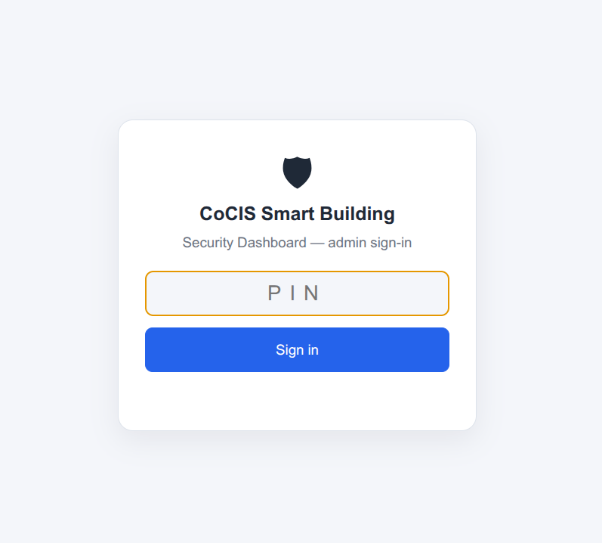
Figure 6: Security Dashboard sign-in page
The sign-in page in Figure 6 uses the admin PIN, with the same three-try lockout as the serial console.
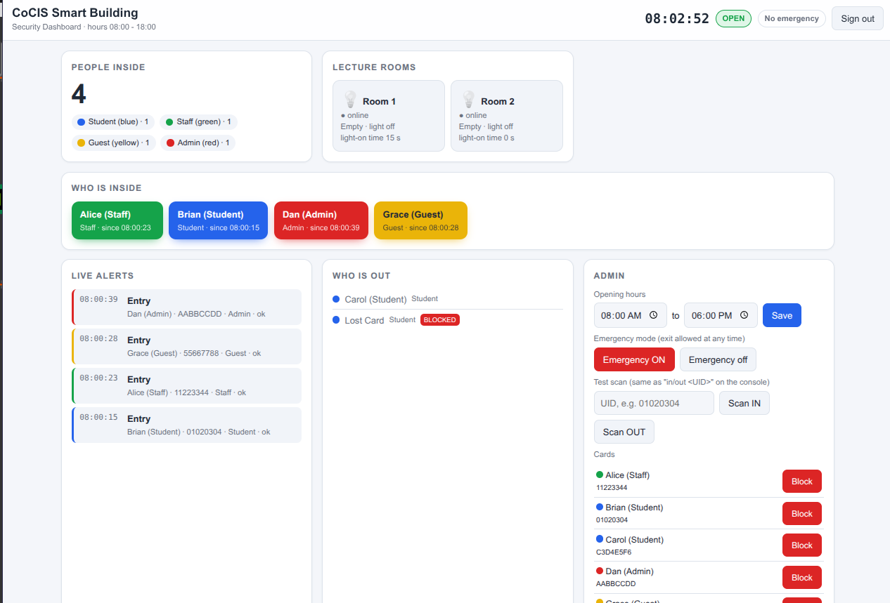
Figure 7: Security Dashboard showing occupants, live alerts and the admin panel
Figure 7 shows the dashboard with four people inside. Each card colour marks a role (Alice green Staff, Brian blue Student, Dan red Admin, Grace yellow Guest). Live alerts list every entry, Who is out shows Carol and the blocked lost card, and the Admin panel sets the opening hours, emergency mode and test scans, and blocks cards.

3. Wokwi simulation link
Wokwi link: https://wokwi.com/projects/479973565868386305
Source code: https://github.com/MukyalaDorcusNandy/cocis-smart-system
The Wokwi circuit lives in the repository as cocis_system/diagram.json and cocis_system/wokwi.toml. Open cocis_system in VS Code, build the firmware, then start the simulator.
To run it locally in VS Code: build the cocis_system project with ESP-IDF v6.0.1 (rm -f sdkconfig once, then idf.py build), then press F1 and choose Wokwi: Start Simulator. Click inside the Wokwi terminal to type commands; help lists them. A quick demonstration:
- Click the ENTRY reader, pick the Green Card and press Tap: Alice enters, the green LED lights, the LCD shows WELCOME Alice / Staff GREEN card and the entry servo opens.
- Click PIR 1: room 1 lights up and the hub prints [HUB] room 1 OCCUPIED, light ON.
- login 1234, then clock 19:00: the building is now closed.
- Tap the Green Card on the EXIT reader (or out 11223344): exit is denied outside hours (LCD Building closed). emergency on, then tap again: exit is granted.
- syslog 10: the same events, read back from the SD card.
- Open http://localhost:8180, sign in with the PIN, and tap the NFC Tag (unknown card): a red SECURITY ALERT pops up.

4. Individual video demonstrations
Each member recorded their screen while explaining the code they wrote and showing it running in Wokwi.
Table 7: Individual video demonstrations
Member | Video link | What the video shows
Mukyala Dorcus Nandy | https://youtu.be/gq0o-ey0CB0 | rfid.c MFRC522 driver (register access over SPI, WUPA, anticollision, BCC, debounce, two readers on one bus with separate CS); access_control.c decision rules, roles and colours, buzzer pattern. Demo: tapping the Wokwi cards on both readers, granted/denied, colours
Mariam Wambui | https://drive.google.com/file/d/1Dl7ZczJUdglOLgL2aBQ-jnIRXcfrd1G2/view?usp=sharing | room_control.c: PIR polling, the vacancy timer and light control; the room provider adapter and the rooms panel on the dashboard. Demo with PIR 1 and PIR 2 in Wokwi and in the browser
Kisomose Arnold Patrick | CoCIS_Project.mp4 - Google Drive | lcd_display.c (PCF8574 bits, 4-bit mode, LCD task and queue); the circuit in diagram.json (zones, readers, LCD), pin plan, Wokwi.toml (port forward), sdkconfig. defaults. Demo of the LCD messages and the circuit
Katumba Joshua Mugwanya | https://drive.google.com/drive/folders/14ZIB52WZ6EdENuqAL92zt4JbBE2MgZL6?usp=drive_link | storage, schedule, auth, management: SD log, opening hours, PIN hashing and lockout.
Nannyombi Shakiran | https://youtu.be/k4SUe7A5VBc | main.c start-up order, hub.c, wifi.c, web_dashboard.c and dashboard.html: hub queue, offline detection, alert ring, event listeners. Demo of rooms, roomfail, Wi-Fi, and the live dashboard

5. Individual contributions
Each member owned one part of the system, developed it on their own branch and merged it through a pull request. The parts were then brought together and tested as one firmware on the integrate branch.

5.1 Mukyala Dorcus Nandy: entrance and access control
- Designed the entrance as three tasks (console, access, actuator) joined by scan_queue and actuator_queue.
- Wrote the access decision: registered card, blocked card, anti-passback, opening hours and emergency exit.
- Drove the hardware: entry and exit servos (LEDC PWM), green and red LEDs, buzzer.
- Built the serial console with simulated RFID (in / out), character echo, PIN masking, and the command table other components register into.
- Kept the “who is inside” record and the entrance log; added card blocking saved in NVS.
- Added the entrance parts to diagram.json and wrote the first README.
- Wrote the rfid component: MFRC522 register access over software SPI (bit-banged, mode 0, own MISO per reader), soft reset and antenna set-up, WUPA request, anticollision with BCC check, debounce, and the rfid task that calls entrance_submit_scan().
- Made the driver work with the two official Wokwi board-mfrc522 readers on one SPI bus (separate chip selects 5 and 23); the version check accepts any answer except 0x00 / 0xFF.
- Added card roles and colours (entrance_role_t, entrance_role_name(), entrance_role_color()) and matched the card table to the Wokwi presets (Blue Brian, Green Alice, Yellow Grace, Red Dan, orange Key Fob blocked); role/colour/since-time in inside and users.
- The buzzer pattern: one short beep when granted, two long beeps when denied.

5.2 Mariam Wambui: lecture-room occupancy and lighting
- Wrote the room task: PIR polling every 100 ms, light on with motion, off after the vacancy delay.
- Added light-on time tracking and the room status record (occupied, light on, light-on seconds).
- Wired and tested both PIR sensors and room LEDs in Wokwi.
- Updated the application start-up (app_main) to run the rooms.
- Rooms on the web dashboard: room cards (online/offline, occupied, light, light-on time) fed by the room provider adapter (web_room() in main.c → hub_get_room()).
- Room part of the test plan (sections 3, 4 and the dashboard room checks).

5.3 Kisomose Arnold Patrick: room component, project structure, circuit and entrance LCD
- Made room_control one reusable component that runs room 1 and room 2 in the same firmware, each with its own pins, task and mutex.
- Wrote room_config.h (pin plan, poll interval, vacancy delay, heartbeat) and the status callback that reports each room to the rest of the system.
- Set up the single-ESP32 project (cocis_system) and the shared components/ layout.
- Maintained the repository: .gitignore, removal of the old per-node folders, and PROJECT_STRUCTURE.md.
- Wrote the lcd_display component: the PCF8574 I2C backpack bits (RS, EN, backlight, D4–D7), the HD44780 4-bit start-up, the welcome / denied / idle screens, and the lcd task fed by a queue from an entrance event listener, so the entrance never waits for the slow I2C bus. The system keeps running if no LCD answers.
- Wired the two board-mfrc522 readers (shared SCK 16 / MOSI 17, CS 5 and 23, MISO 35 and 36, RST to 3.3 V) and the LCD (SDA 15, SCL 2) in diagram.json, laid the circuit out in zones so no parts overlap, and checked the pin plan has no clashes.
- Wokwi.toml: the port forward localhost:8180 → ESP32 port 80. sdkconfig.defaults: large app partition, 4 MB flash, bigger event task stack and HTTP header size.

5.4 Katumba Joshua Mugwanya: storage, schedule, authentication and management
- storage: NVS settings, SD card mounting over SPI, the ACCESS.LOG file, the RAM log and the RAM-only fallback.
- schedule: the single simulated clock, opening hours saved in NVS, and the shared schedule_log used by every component.
- auth: salted SHA-256 PIN storage, constant-time comparison, 3-try lockout, 120 s idle timeout, first-boot default PIN.
- management: the admin commands login, logout, setpin, hours, clock, syslog, emergency, block, unblock.
- web sign-in security: auth_check_pin() shares the lockout counter with the console login; random token sessions (10 min idle); 401 for a missing or old token (the page returns to sign-in); WEB,... log lines for every web action and AUTH,web login ... for sign-ins.

5.5 Nannyombi Shakiran: system integration and hub
- Owned cocis_system/main/main.c: the start-up order of all components and error checks on each. Shared services start first (storage → schedule → auth), then the hub, then management commands, then the two rooms, then the entrance last so every command is registered before the console prints help.
- Owned the hub (hub.c, hub.h): one FreeRTOS queue for room reports and entrance events, 15 s offline detection, and the rooms / roomfail commands.
- Agreed the message format with the group. Room messages are room_status_t (room number, occupied, light, light-on seconds, sequence). Entrance messages are entrance_event_t (entry/exit, UID, name, granted, reason, inside count). Both are delivered through callbacks that only enqueue, so a slow hub cannot stall a terminal.
- Made access_control the single owner of building occupancy. The hub announces granted entries and exits; rooms reads the count from the entrance instead of keeping a second copy.
- Handled a temporarily silent terminal: after 15 s without a room heartbeat the hub marks that room OFFLINE, logs it, and restores ONLINE on the next report. roomfail is the integration test for that path.
- Detected duplicate room reports with the per-room sequence number, and printed a message if the hub queue was full.
- Wrote the integration tests in docs/TEST_PLAN.md sections 0 (boot / first hub reports), 3 (rooms to hub) and 4 (offline detection).
- Wi-Fi + web dashboard: wifi.c (station on Wokwi-GUEST, retry forever, non-blocking), web_dashboard.c (HTTP server, JSON API, alert ring of 30 with a mutex, wifi command) and dashboard.html (live view, toasts, beeps, admin actions).
- Changed entrance_set_event_cb() to allow several listeners (hub + web), and updated the start-up order in main.c (web commands before entrance_start(), readers and Wi-Fi after). Merged the feature branches.

6. Testing and limitations
The firmware builds with no errors on ESP-IDF v6.0.1. It was tested in Wokwi with the test steps in docs/TEST_PLAN.md, covering boot, RFID readers, card roles and colours, the entrance LCD, card scans, opening hours, rooms, offline detection, login security, the SD log, Wi-Fi and the web dashboard.

6.1 Integration tests
Table 8: Integration tests and what each one shows
Test | What it shows
Boot (TEST_PLAN 0.5) | Both rooms report to the hub: ONLINE, then EMPTY, light OFF
Granted entry (1.1) | Hub prints building occupancy: 1 after the entrance decision
PIR click (3.1–3.4) | Room task and hub both print the occupancy / light change; rooms shows ONLINE and light-on time
roomfail without login (4.1) | Privileged integration command is protected
roomfail 2 on (4.2–4.3) | After 15 s the hub marks room 2 OFFLINE; the room LED still works (only the report path is cut)
roomfail 2 off (4.4) | Next heartbeat brings the room ONLINE again
rooms after scans | Building occupancy matches inside (one owner)

6.2 Limitations
- The MFRC522 driver only reads the card UID (WUPA, anticollision level 1). It does not do card select, authentication or reading card memory, and a 7-byte UID is cut to its first 4 bytes.
- The web dashboard uses HTTP, not HTTPS, so the PIN and token are not encrypted on the network. A real system needs HTTPS.
- Only one web session at a time: a new sign-in replaces the old token.
- Registered cards are fixed in the firmware; adding a card means rebuilding.
- A PIR detects movement, not people, so rooms show occupied or empty but not who or how many.
- The “who is inside” record is kept in RAM and is reset by a reboot. Blocked cards and settings are kept in NVS.
- The clock is simulated and starts at 08:00 at every boot (no real-time clock or internet time).
- GPIO 2 and 15 (LCD I2C) are ESP32 strapping pins. On a real board, other pins would be safer.
- There is one admin role with one PIN.
- Overnight opening hours (close after midnight) are not supported.
- Restarting the Wokwi simulator usually clears flash and the SD card; NVS persistence can only be shown with a reset inside the same simulation.

